|  |
| --- |
| Midland Geotechnical Society  Information for Speakers |

Date: October 2025

The Midland Geotechnical Society

Registered Charity No 514610

Contents

Section Page

1. The Society 4

2. Meeting Arrangements 4

2.1 The Convenor 4

2.2 Meeting Details 4

2.3 Travel and Accommodation 4

2.4 Sponsorship 5

3. The Meeting 5

3.1 Presentation Facilities 5

3.2 Synopsis 5

3.3 Record of the Meeting 5

Appendices

Appendix 1 University Map

Appendix 2 Lecture Theatre G31 Details

# The Society

The Society was formed in 1954 and has been extremely successful in providing an independent forum for geotechnical engineering in the Midlands since then. Membership stands at about 250 members, the majority of whom are practicing engineers. Attendance at the meetings averages about 40 to 80, with some meetings attracting over 100 people.

The subscription fee for the Society is £15. Unfortunately, this does not enable a fee to be paid to speakers, but their travel and accommodation expenses can be met if required.

# Meeting Arrangements

## The Convenor

The committee will appoint one of their members as Convenor for the meeting. The Convenor will ensure the smooth running of the evening and, well before the meeting, will liaise with the Speakers, keeping them informed and answering any enquiries. The Convenor will meet the Speakers on arrival.

Should the Speakers have difficulty in contacting the Convenor, they are welcome to contact the Society via the contact us details on the website here

https://midlandgeotechnicalsociety.org.uk/contactus.shtml

## Meeting Details

Meetings are generally held in the old Engineering Building (Y3) at the University of Birmingham. Meetings usually take place on the first Monday in the month, starting at 6.30pm. A map of the University is included in Appendix 1. Occasionally, meetings are held elsewhere – confirmation of location and directions to other venues can be found at the Society’s website linked below.

<http://www.midlandgeotechnicalsociety.org.uk/meetings.shtml>

**The presentation should be of 50 to 60 minutes duration and finish by 7.30pm. There will be about ten minutes taken up at the beginning of the meeting for the Chair of the Committee to make announcements and introduce the Speakers. There will be time for questions and discussion before the meeting closes at about 8.00pm.**

## Travel and Accommodation

Speakers are asked to arrive by 6pm on the day of the meeting. This allows sufficient time for them to be shown to the lecture theatre and set up their equipment. There will also then be the opportunity for refreshments (in the Shell Lounge (G37) of the old Engineering Building (Y3), if at the University of Birmingham) before the lecture begins.

Should an overnight stay be necessary, the Society can arrange accommodation. As stated previously, the Society will cover expenses associated with travel and accommodation. **Please notify the Convenor if you require accommodation.**

Reimbursement of travel expenses can be made either through the Convenor or directly with the Treasurer after the event. Please provide details either the mileage (paid at 25p per mile), if travel was by car, or provide train, bus, or taxi ticket or receipt. We encourage people to travel by public transport where possible. Please also confirm where you would prefer the cheque to be posted.

## Sponsorship

The MGS offers company sponsorship of the lecture series to cover costs while maintaining a low membership fee. Each lecture is sponsored by a Patron sponsor who may display a trade stand inside or outside the lecture theatre. The patron sponsor is also invited to give the vote of thanks at the end of the lecture. Details of the sponsors are given at the Society’s website linked below.

<http://www.midlandgeotechnicalsociety.org.uk/meetings.shtml>

# The Meeting

## Presentation Facilities

University facilities include a digital projector with USB socket for a memory stick, as well as a facility for laptop connection. Appendix 2 provides further information on a typical lecture theatre used for meetings.

For presentation facilities at other venues, please contact the Convenor.

## Synopsis

A short (100 to 150 word) synopsis of the lecture, together with a brief CV of the Speaker, should be provided at least 4 weeks before the meeting, in time for it to be circulated to members of the Society with the notice of the meeting.

Members of the audience often ask for a list of references quoted in the lecture, and for copies of design charts when these have been shown. These can be provided in the copy of the presentation posted on the website after the meeting (see Section 3.3 below). We discourage the use of photocopying material for the audience to avoid wastage and minimise costs.

## Record of the Meeting

The Society would like the opportunity to record the meeting and provide the recording on the MGS website for reference purposes. If, due to confidentiality reasons, the Speaker would prefer not to have the talk recorded, the Society would request a copy of the presentation slides in PDF format with any sensitive slides removed. Should the Speaker, for any reason, not wish for the presentation to be posted on the website, a meeting report may be taken during the lecture for the record.

**Finally, we would like to thank you for your time and effort in supporting the Midland Geotechnical Society by making this presentation.**

###### University Map

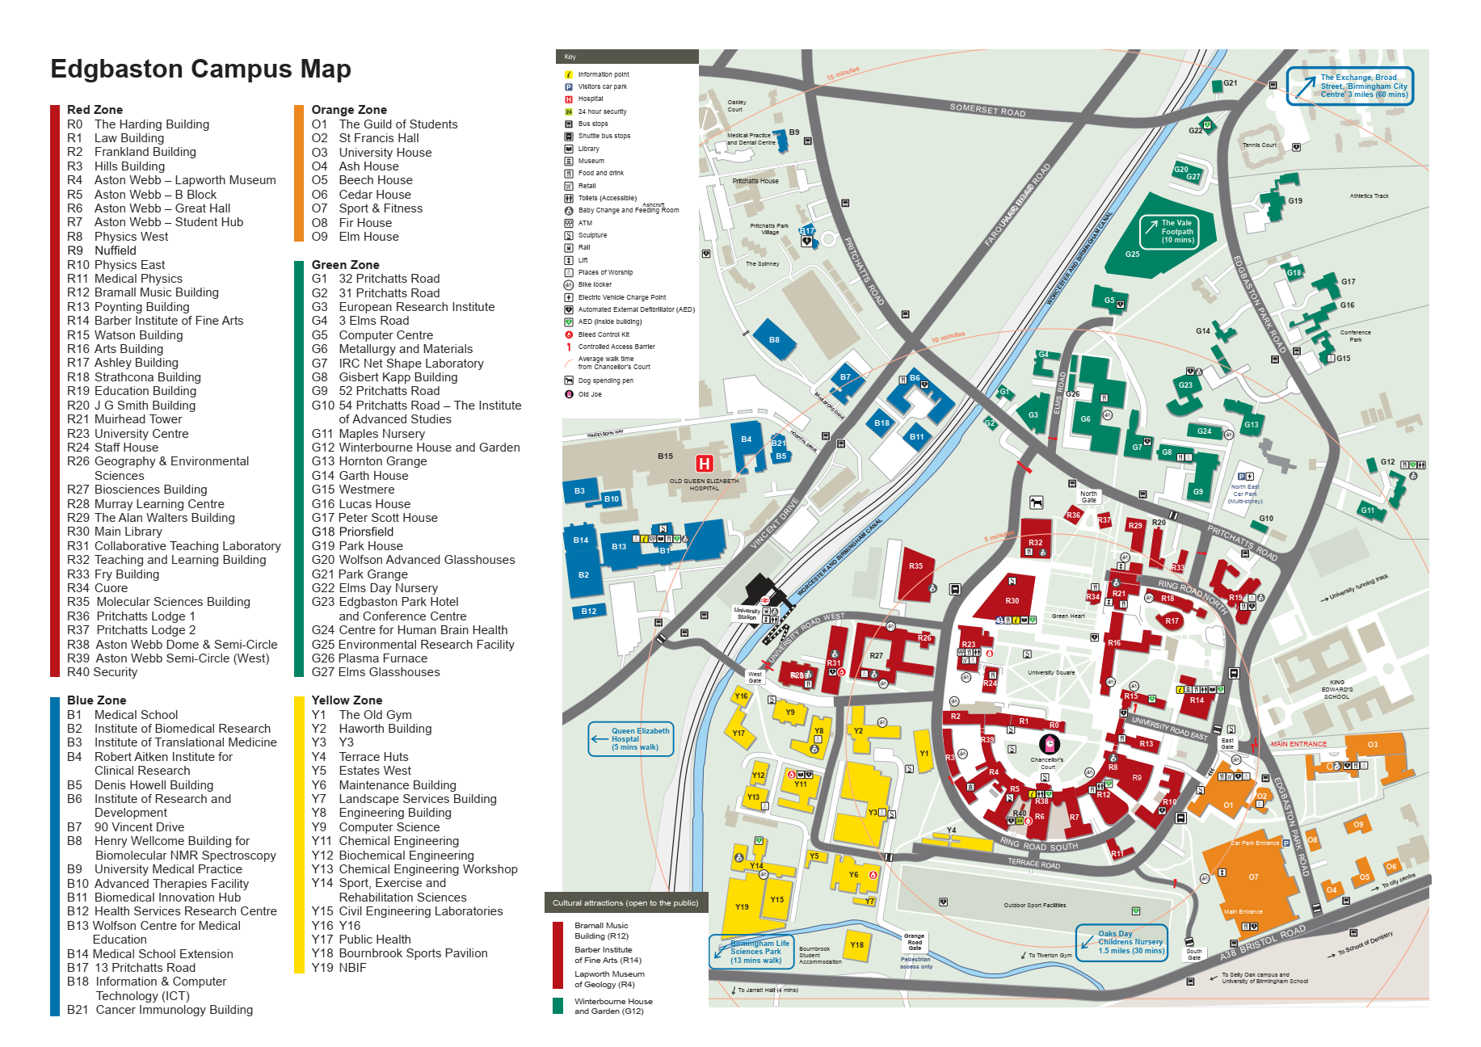

The old Engineering Building is numbered Y3 on the map. For details on getting to Edgbaston Campus please visit: https://www.birmingham.ac.uk/contact/direction

###### Typical Lecture Theatre Details

|  |  |
| --- | --- |
| Seating   * Number of Seats: 100-300 * Type of Seating: Tiered Fixed Seating   Boards and Screens   * Chalk Boards: 0 * Drywipe Boards: 6 * Projection Screens: 1   Other equipment   * Adaptor - USB-C: 1 * Blu-ray Player: 1 * Camera - White Board Capture: 2 * Hearing Aid Loop Transmitter: 1 * Lectern PC: 1 * Podium Monitor: 1 * Radio Microphone Lapel: 1 * Touch panel: 1 * Visualiser: 1 | Accessibility Grading   * Mobility impairment: M2 * Hearing impairment: H1 * Hearing assistance available: set hearing aid to 'T' - IR receiver available from LRAT   Other information   * Panel Type: Extron touch * Wireless network available * Lecture capture Plus (Whiteboard Capture) available * HDMI cable available * Boundary mic available * Phone in room * Height adjustable lectern |