
The Midland Geotechnical Society
Advances in understanding of Mercia Mudstone
Half Day Seminar
Afternoon of Wednesday 8th July 2026
To be held at the University of Birmingham, Edgbaston, Birmingham, B15 2TT
Seminar Programme
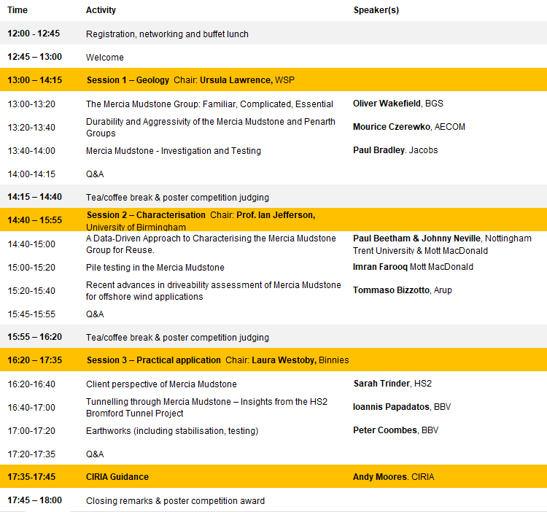

Registration
If you would like to attend, please register by following this link:
Midland Geotechnical Society Advances in Understanding the Mercia Mudstone – Fill in form
If you have any questions relating to the seminar or registration, please email Lindsay.Burt@arup.com with ‘MGS MMG Seminar’ in the email subject.

Poster Competition
In addition to the presentations and networking opportunity, attendees are also invited to participate in a poster competition on the topic of the “Advances in understanding of Mercia Mudstone”.
If you would like to submit a poster please register your poster title and lead author here before Wednesday 24th June (ideally earlier) so that we can ensure sufficient boards are available for display.
There will be two categories judged in the competition:
- Lead author has less than 10 years of ground engineering industry experience
- Lead author has more than 10 years of ground engineering industry experience
Prizes of £100 (1st place), £50 (2nd place) and £25 (3rd place) will be awarded for both categories, with judging undertaken by those chairing the three sessions.

Fees for attendance are as follows:
Option | Standard Fee
One delegate place  (MGS Member) | £80
One delegate place  (Non-MGS Member) | £95
One delegate place (Student or Apprentice) | £45
Sponsorship package.  Industry stand to be displayed in the reception area during the seminar and company logo displayed on key information at the seminar. Includes one delegate place. | £250

The MGS committee hope you will take time to join us for what promises to be an informative afternoon discussing advances in understanding of the Mercia Mudstone Group.

