 | Registered Charity Number: 514610
 | Midland Geotechnical Society  Meeting Notice
 | www.midlandgeotechnicalsociety.org.uk
Thank you to the Sponsors of the Society for their Support:  Patron Sponsors  Aecom  Applied Geology  Arcadis  Arup  DTS Raeburn  Geotechnics  Huesker  WSP  Supporting Sponsors  GIP Ltd  M&J Drilling Services  Penguin Recruitment  Typsa  Contact Us  Honorary Secretary: Scott O’Neill-Gwilliams  scott.oneill@aecom.com  Tel: 0121 2148194  Meeting Venue  Meeting starts 7pm  The lecture will be broadcast online via MS Teams. Dial-in details are in this flyer.  Thank you to the Sponsors of the Society for their Support:  Patron Sponsors  Aecom  Applied Geology  Arcadis  Arup  DTS Raeburn  Geotechnics  Huesker  WSP  Supporting Sponsors  GIP Ltd  M&J Drilling Services  Penguin Recruitment  Typsa  Contact Us  Honorary Secretary: Scott O’Neill-Gwilliams  scott.oneill@aecom.com  Tel: 0121 2148194  Meeting Venue  Meeting starts 7pm  The lecture will be broadcast online via MS Teams. Dial-in details at end of this flyer. | This lecture has been supported by sponsorship from:    Monday 7th December 2020  Dr. Sanduni Gunaratne, Coventry University  Improving Resilient Properties of Railway Ballast with Random Fibre Reinforcement  Synopsis:  This talk will be focussed on the addition of randomly oriented fibre reinforcement into ballast matrix. It will explore the findings of the research, specifically, the effect of RFR on the resilient behaviour of ballast using cyclic triaxial tests.  The presentation will discuss the requirement for optimising ballast performance and the improvements to workability, reliability and longevity RFR produces.  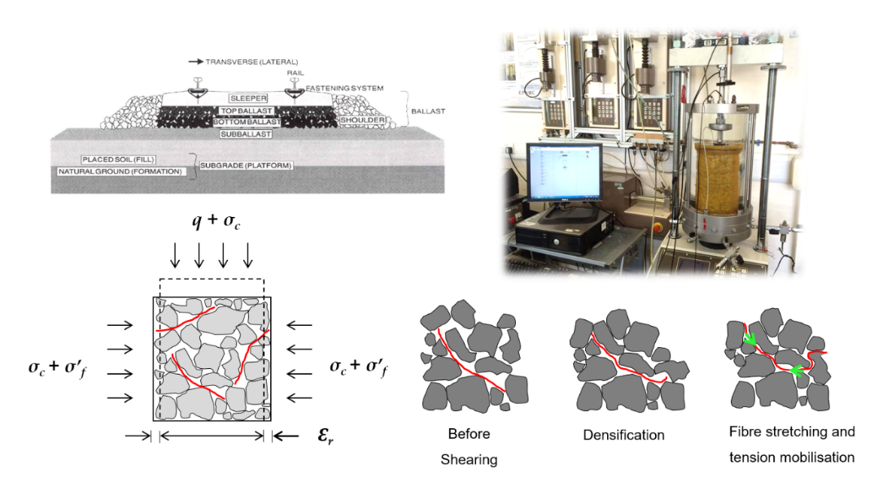  About the Speaker:  Dr. Sanduni Gunaratne is an Assistant Lecturer at Coventry University, who is currently working as an Associate Course Director for Undergraduate Civil Engineering Courses as well.  Sanduni graduated with BSc (Hons) in Civil Engineering degree in 2013, from the faculty of Engineering, University of Moratuwa, Sri Lanka. At the graduation she was awarded academic excellence awards for Geotechnical Engineering and Design Project. She joined the Track 21/ T2F railway research group of University of Southampton in 2014, where her PhD research on ‘Improving resilient properties of railway ballast using random fibre reinforcement’ was carried out.  After completing her PhD, she joined Coventry University in the year 2018 as an Assistant Lecturer in Civil Engineering and is currently involved in teaching and research related to Civil Engineering with the focus of Geotechnical Engineering. Her main research interests are soil strength improvement and development of sustainable construction materials out of natural and waste products.  This season’s lectures...  11th January 2021 – Ian Gardner, Hydrock – Geotechnical Design of Earthworks  1st February 2021 – Steven Miller, Geotechnics Ltd - Contracts and Site Investigation  1st March 2021 – BGA Cooling Prize Presentation. Winner and Title TBC  19th April 2021 – John Mitchell Award – Speakers for 2021 TBC.  10th May 2021 – AGM & Environmental lecture. Peter Braithwaite, University of Birmingham
  MGS Early Career Award - Final
  William Kan, AECOM
  A Q-System Case Study for the Blue Lias Formation
  Mersade Cartwright, Arup
  Visualising Laboratory Tests on a Live Ground Investigation to Aid Scheduling
  Dr. Sanduni Gunaratne, Coventry University
  Improving Resilient Properties of Railway Ballast with Random Fibre Reinforcement
  Each of our three finalists will be giving a 10-minute presentation
  followed by up to 5 minutes of questions. The standard of entries is very high so it’s going to be a tough job for our judging panel of past MGS chairs to determine a winner! Please join us to support our finalists and learn more about the geotechnical challenges some of our members have been working on.
  Meeting Details for 7th December 2020:
  Join Microsoft Teams Meeting
  Join from a video system
  Dial: teams@vmr.arup.com
  Video Conference ID: 122 203 581 0#
  Join by phone (audio only)
  +44 20 3321 5205 United Kingdom, London
  Phone Conference ID: 791 975 132#
  William Kan, AECOM
  A Q-System Case Study for the Blue Lias Formation
  Synopsis:
  This talk will be focused on the use of the Q-system in the engineering geological logging of tunnel faces to verify the primary lining support for the galleries and adits at Hinckley Point C in Somerset, UK.
  The presentation will discuss the ground behaviour by presenting the engineering geological data, supplemented by observations during construction.
  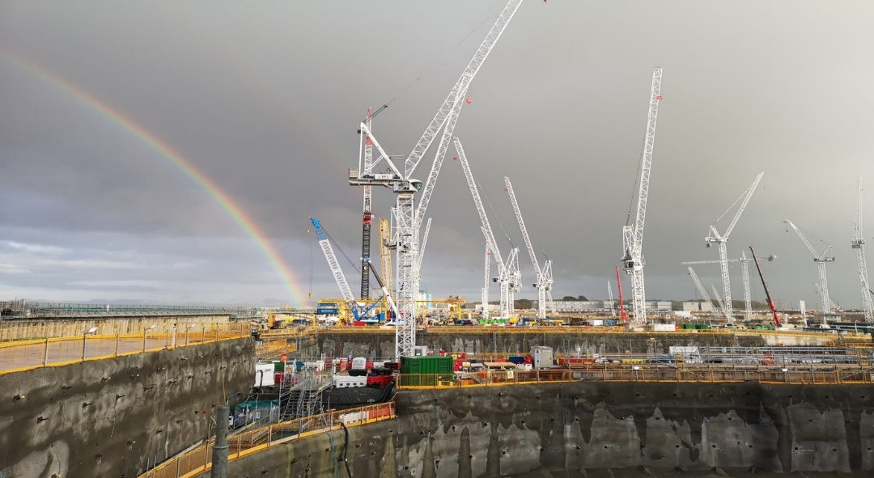
  About the Speaker:
  William is a Chartered Geologist with 7 years of combined design and site experience since achieving a BSc degree in Geological Hazards at the University of Portsmouth. He is currently an Engineering Geologist for AECOM’s Ground, Energy & Transactions Solutions Department, engaged in a variety of projects in the rail, urban development and regeneration sectors. William’s recent involvement was on the new nuclear power station at Hinkley Point ‘C’, initially on site as a member of the AECOM shift team as a rock slope geologist, then as a rock core logging geologist for a 4.5 month ground investigation and finally collaborating in a combined contractor-designer geotechnical site team as a tunnel shift geologist for the delivery of the project’s onshore tunnels and shafts. William is currently a Ground Investigation Supervisor for the A303 road alignment and tunnel scheme.
  Mersade Cartwright, Arup
  Visualising Laboratory Tests on a
  Live Ground Investigation to Aid Scheduling
  Synopsis:
  This talk will be focussed on the implementation of PowerBI on a large-sclae linear ground investigation, to aid with the scheduling of a high volume of laboratory tests.
  The presentation will discuss the contribution of digital innovation in ensuring efficiency in the three-dimensional coverage of testing and the consequent contribution for later geotechnical design stages.
  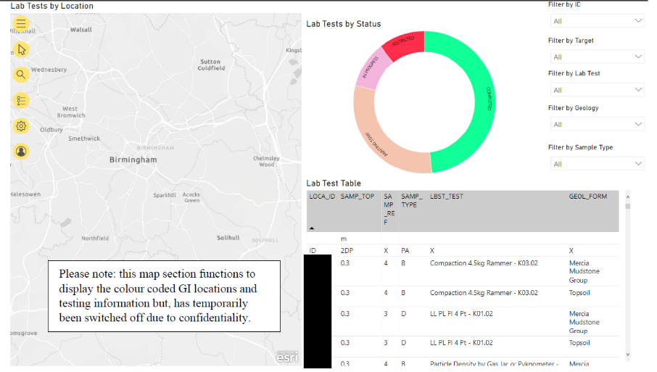
  About the Speaker:
  Mersade is an Engineer at Arup with 8 years’ experience gained in the geotechnical team and is currently completing her training towards her IEng. She has experience in both technical and digital based geotechnics. Mersade has experience built on GIs, data digitisation, ground modelling and general report work and has worked on projects such as Midland Line Extension (Croxley), the A120, various gas works, power stations and HS2. Last year, she was part of a team of investigation supervisors responsible for site supervision for technical assurance on one of the UKs largest GI projects.

